TASK – 10
- 10 Linux commands

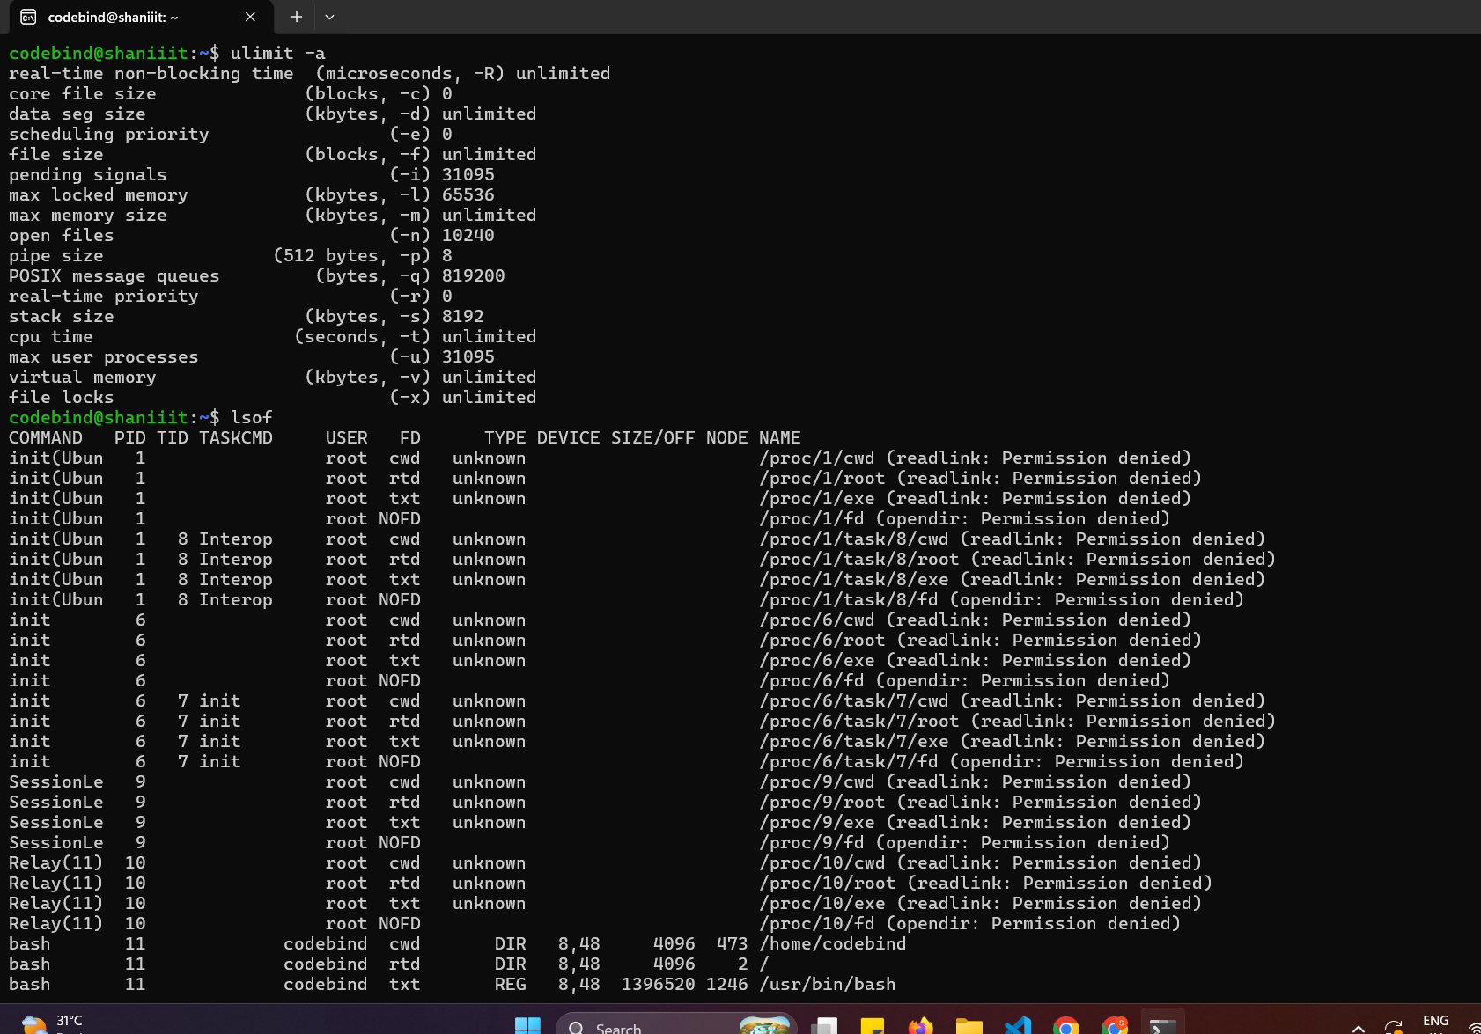

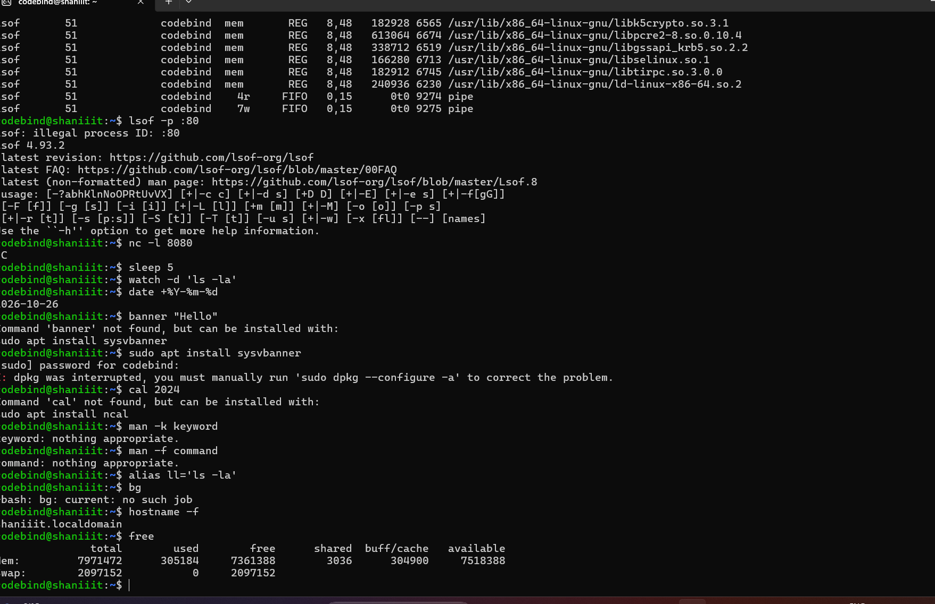

- Analyze 5 unique products using the 4 analytics types

- Smart Weather Forecasting System
  - Descriptive: Heavy rainfall occurred over the past three days.
  - Diagnostic: Low-pressure conditions caused the rainfall.
  - Predictive: More rainfall may occur in the coming days.
  - Prescriptive: Issue weather alerts and prepare flood protection measures.
- Cyber Threat Detection System
  - Descriptive: The system detected 500 failed login attempts.
  - Diagnostic: Attackers may be attempting to access user accounts.
  - Predictive: A successful cyberattack may occur if attempts continue.
  - Prescriptive: Block suspicious IP addresses and enable multi-factor authentication.
- Smart Home Energy Management System
  - Descriptive: Electricity consumption increased by 30%.
  - Diagnostic: Air conditioners and other appliances consumed more power.
  - Predictive: Electricity bills may increase next month.
  - Prescriptive: Optimize appliance usage and automatically switch off unused devices.

- Smart Patient Monitoring System
  - Descriptive: A patient's heart rate increased above the normal range.
  - Diagnostic: The increase may be due to stress, fever, or another health issue.
  - Predictive: The patient's condition may worsen if the abnormal reading continues.
  - Prescriptive: Alert healthcare staff and arrange medical assessment.
- Smart Crop Monitoring System
  - Descriptive: Crop growth decreased by 20% in a field.
  - Diagnostic: Insufficient water or poor soil conditions may be responsible.
  - Predictive: Crop yield may decrease at harvest time.
  - Prescriptive: Adjust irrigation and apply suitable nutrients based on soil tests.

3. Analyze business data capture and growth using Python
Data Analysis of Muthoot Finance Using Python

How is data captured?

Muthoot Finance captures data through loan applications, branch transactions, gold valuation, loan repayments, and customer service records.

What data is collected?
- Customer and branch details
- Loan amount and gold value
- Repayment and overdue records
- Transaction dates and payment status

How is data stored?

Data can be stored in databases such as SQL databases and internal financial systems, then exported to CSV or Excel for analysis.

How is data cleaned using Pandas?

Pandas helps remove duplicate records, handle missing values, correct data types, and organize loan records.

How are NumPy and Pandas used?
- NumPy: Calculates average loan amounts, totals, and numerical statistics.
- Pandas: Filters customer records and summarizes loans by branch.

How is Matplotlib used?
Matplotlib creates charts to compare loan amounts, repayment rates, and overdue loans across branches

What is Jupyter Notebook's role?
Jupyter Notebook allows analysts to run Python code step by step, view tables and charts, and document their analysis in one place.
4. Data Analysis With and Without NumPy (Muthoot Finance- Group)
Refer the document attached
5. Complete NumPy and Pandas hands-on exercises in Jupyter
(Refer the colab file attached)

